School Uniform
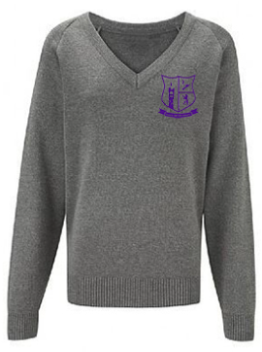
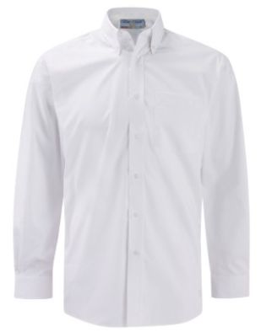
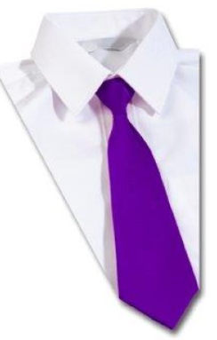
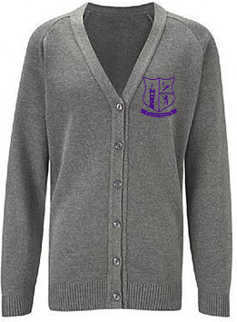
White shirt and school purple tie

Grey school jumper or cardigan with school logo

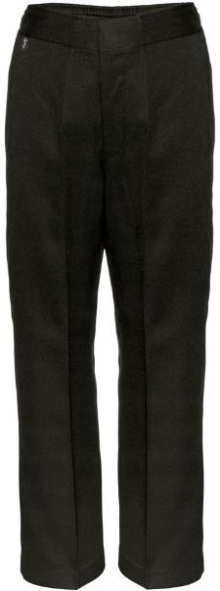
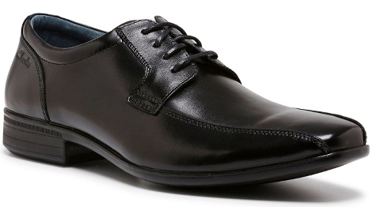
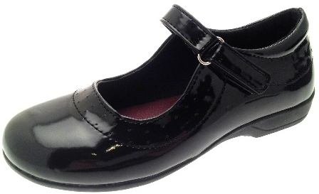
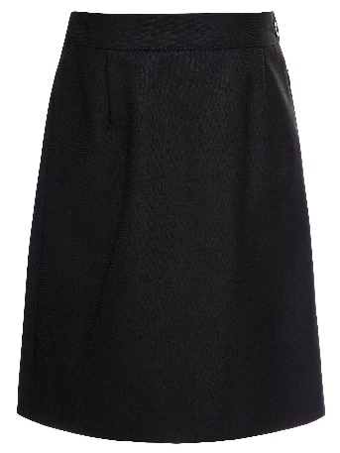
Plain black shoes with no other colour, logo/motif or similar.
Black knee length tailored skirt

Black trousers of classic fit (straight cut). Trousers must be full length (touch the heel of the shoe). Trousers should not be tight or loose fitting

The following is not acceptable
Jeans, denim neu trousers of excessively stretchy material e.g. ‘leggings, jeggings, combats’.
Coats or hoodies worn in lessons
These items can be bought online by visiting www.constructiv.co.uk or by visiting Constructiv Clothing, Mochdre Industrial Estate, Newtown. SY16 4LE. 01686 610 890.
Parents may be eligible to receive grants to purchase school uniform from the local authority.

Sports Clothing

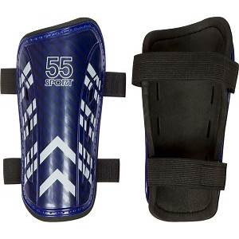
Compulsory Sports Clothing
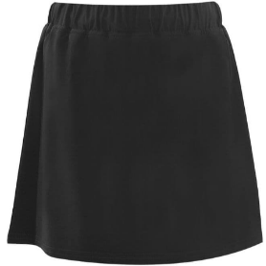
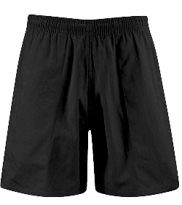
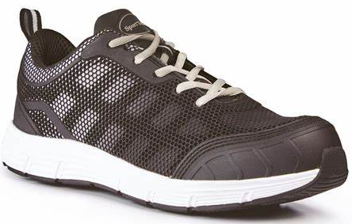
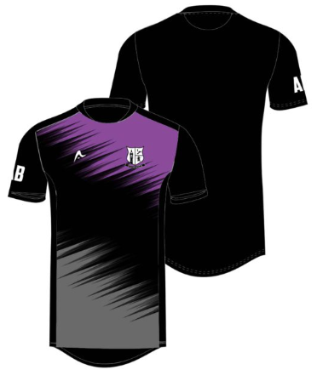
Shorts/Skorts/Leggings/Tracksuit bottoms Plain Black Only
Or
The School’s Shorts/Skorts/Tracksuit Bottoms (below)
Shin pads, Trainers, and studded sports boots
Bro Hyddgen Sports T-Shirt
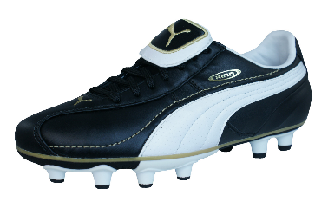

Optional Sports Clothing
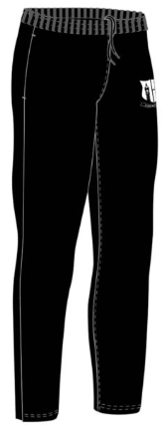
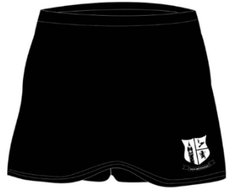
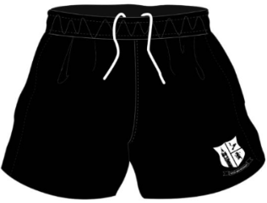
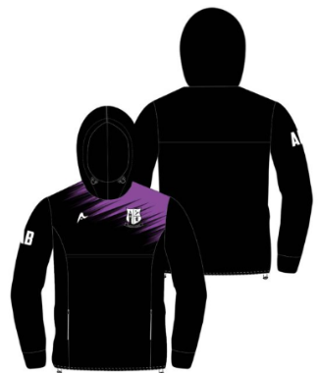
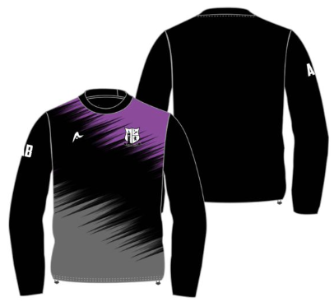
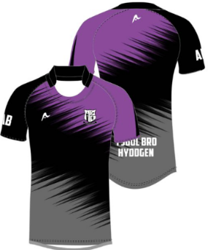

** To be worn in sports lessons only

These items can be bought online by visiting www.constructiv.co.uk or by visiting Constructiv Clothing, Mochdre Industrial Estate, Newtown. SY16 4LE. 01686 610 890.

Make-up & Nails
• Make-up should not be noticeable.
• No nail varnish or any nail extensions (acrylic or gel) to be worn at all.
The school will ask pupils to remove any make-up or nail varnish which is obvious or/and excessive.

Jewellery
• One flat ring is allowed to be worn.
• One small pair of studs in the lower ear lobes.
- Other piercings are not allowed.
Students should not wear any expensive jewellery e.g. watches. Items are brought into school at the student’s own risk.

Hair Styles
• Hair should be a natural colour.
• Hair styles should not be extreme in style or draw attention.

Incorrect uniform
Any pupils not conforming to any of the school uniform rules will be asked to go to the office and offered the correct uniform, letters will be sent home to parents, if available, or given the opportunity phone parents for uniform to be brought to school from home. Sanctions will be imposed for pupils who do not comply.
*Some companies brand their clothing as ‘school wear’. This does not necessarily mean that they are suitable for use at Ysgol Bro Hyddgen. Please contact the school and ask to speak to a member of the leadership team or head of year if you are unsure about the appropriateness of an item of clothing.

